**Data in Evaluation of dapog seed rate**

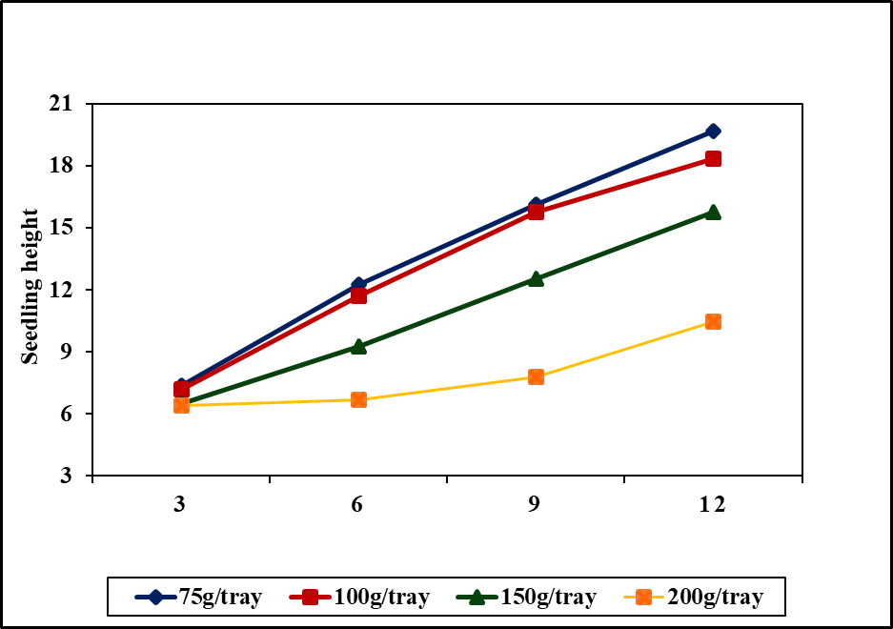

**Changes in Seedling height according to the seed rate**

**Bg 374**

**Days after sowing**

**Core relation for V1**

The SAS System 18:31 Wednesday, December 17, 2018 1

The CORR Procedure

6 Variables: trt sheight sdrywgt totalrtln chrlcont spersqmtr

Simple Statistics

Variable N Mean Std Dev Sum Minimum Maximum

trt 12 2.50000 1.16775 30.00000 1.00000 4.00000

sheight 12 13.92083 3.59087 167.05000 9.55000 18.70000

sdrywgt 12 0.08262 0.02031 0.99145 0.05800 0.10800

totalrtln 12 229.61658 57.90442 2755 118.83160 320.38140

chrlcont 12 31.36667 1.64114 376.40000 29.30000 34.10000

spersqmtr 12 217.60795 37.36961 2611 168.52300 271.29320

Pearson Correlation Coefficients, N = 12

Prob > |r| under H0: Rho=0

trt sheight sdrywgt totalrtln chrlcont spersqmtr

trt 1.00000 -0.99045 -0.90536 -0.83578 -0.23244 0.99373

<.0001 <.0001 0.0007 0.4672 <.0001

sheight -0.99045 1.00000 0.94475 0.85458 0.25014 -0.98792

<.0001 <.0001 0.0004 0.4330 <.0001

sdrywgt -0.90536 0.94475 1.00000 0.87115 0.29898 -0.90598

<.0001 <.0001 0.0002 0.3452 <.0001

totalrtln -0.83578 0.85458 0.87115 1.00000 0.21893 -0.85723

0.0007 0.0004 0.0002 0.4942 0.0004

chrlcont -0.23244 0.25014 0.29898 0.21893 1.00000 -0.20292

0.4672 0.4330 0.3452 0.4942 0.5271

spersqmtr 0.99373 -0.98792 -0.90598 -0.85723 -0.20292 1.00000

<.0001 <.0001 <.0001 0.0004 0.5271

**Core relation for Core relation for V2**

The SAS System 18:31 Wednesday, December 17, 2018 2

The CORR Procedure

6 Variables: trt sheight sdrywgt totalrtln chrlcont spersqmtr

Simple Statistics

Variable N Mean Std Dev Sum Minimum Maximum

trt 12 2.50000 1.16775 30.00000 1.00000 4.00000

sheight 12 16.05833 3.67536 192.70000 10.32000 19.86000

sdrywgt 12 0.11605 0.02305 1.39259 0.08030 0.14900

totalrtln 12 338.57693 22.18014 4063 304.02600 372.87560

chrlcont 12 31.74167 1.79365 380.90000 29.50000 35.70000

spersqmtr 12 183.18944 34.77137 2198 138.56406 231.51674

Pearson Correlation Coefficients, N = 12

Prob > |r| under H0: Rho=0

trt sheight sdrywgt totalrtln chrlcont spersqmtr

trt 1.00000 -0.95804 -0.85149 -0.96519 0.13672 0.98857

<.0001 0.0004 <.0001 0.6718 <.0001

sheight -0.95804 1.00000 0.85279 0.92113 -0.32246 -0.94388

<.0001 0.0004 <.0001 0.3067 <.0001

sdrywgt -0.85149 0.85279 1.00000 0.88298 -0.13187 -0.80957

0.0004 0.0004 0.0001 0.6829 0.0014

totalrtln -0.96519 0.92113 0.88298 1.00000 -0.20182 -0.91934

<.0001 <.0001 0.0001 0.5293 <.0001

chrlcont 0.13672 -0.32246 -0.13187 -0.20182 1.00000 0.05189

0.6718 0.3067 0.6829 0.5293 0.8728

spersqmtr 0.98857 -0.94388 -0.80957 -0.91934 0.05189 1.00000

<.0001 <.0001 0.0014 <.0001

**Data during nursery period until 12 days**

|  |  |  |  |  |
| --- | --- | --- | --- | --- |
|  | Broadcasting | Random Transplanting | Mechanical Transplanting | Parachute |
| 3 | 4.03 | 5.17 | 5.13 | 5.22 |
| 6 | 7.57 | 7.43 | 7.883333333 | 7.95 |
| 9 | 10.99 | 10.82333333 | 11.03666667 | 11.07466667 |
| 12 | 16.15666667 | 15.86333333 | 16.00666667 | 16.10333333 |

|  |  |  |  |  |
| --- | --- | --- | --- | --- |
| DAS | Broadcasting | Random Transplanting | Mechanical Transplanting | Parachute |
| 3 | 4.503 | 5.386666667 | 5.266 | 5.266666667 |
| 6 | 8.34 | 8.28 | 8.37 | 8.456666667 |
| 9 | 11.34 | 11.28333333 | 11.31333333 | 11.43666667 |
| 12 | 17.34 | 16.88333333 | 17.08333333 | 17.17 |

|  |  |
| --- | --- |
| **Treatment** | **Total root length (cm)** |
| BC | 549.6874 |
| RT | 319.4599 |
| MT | 359.8712 |
| PA | 539.1324 |

|  |  |
| --- | --- |
| **Treatment** | **Total root length (cm)** |
| BC | 558.4719 |
| RT | 354.3483 |
| MT | 426.9147 |
| PA | 552.5194 |

|  |  |  |  |  |
| --- | --- | --- | --- | --- |
|  | Broadcasting | Random Transplanting | Mechanical Transplanting | Parachute |
| SDW | 0.132133333 | 0.109066667 | 0.107666667 | 0.122733333 |

|  |  |  |  |  |
| --- | --- | --- | --- | --- |
|  | Broadcasting | Random Transplanting | Mechanical Transplanting | Parachute |
| SDW | 0.3033 | 0.12 | 0.143833333 | 0.291766667 |

**Data after field establishment**

|  |  |  |  |  |
| --- | --- | --- | --- | --- |
|  | BC | RT | MT | PA |
| 7 | 30.35952381 | 25.10277778 | 25.2 | 28.15925926 |
| 14 | 43.66944444 | 31.68888889 | 31.84391534 | 35.3952381 |
| 21 | 48.33333333 | 40 | 40.25833333 | 44.91111111 |
| 28 | 56.75714286 | 47.55833333 | 48.06666667 | 51.46666667 |
| 35 | 68.59925926 | 57.23333333 | 58.2 | 60.06666667 |
| 42 | 79.40740741 | 68.18888889 | 69.06666667 | 70.5 |

|  |  |  |  |  |
| --- | --- | --- | --- | --- |
|  | BC | RT | MT | PA |
| 7 | 43.19333333 | 32.18181818 | 32.87037037 | 34.32424242 |
| 14 | 49.03333333 | 40.2 | 41.7 | 43.2 |
| 21 | 58.0976431 | 49.43333333 | 50.38518519 | 55.15016835 |
| 28 | 66.66296296 | 60.04242424 | 61.11111111 | 63.53333333 |
| 35 | 78.3 | 70.44550265 | 71.23037037 | 73.53181818 |
| 42 | 89.94166667 | 79.06507937 | 79.93518519 | 82.95707071 |

The transplanted plants including Random transplanted, Mechanicaly transplanted and Parachute shows significantly low height (P<0.05) at early period after field establishment (7 DAS, 14DAS) compared to the Broadcasting in the two varieties Bg 360 and Bg 374 as the growth of the plants was disturbed when uprooting for field establishment. In the Mechanicaly transplanted and Random transplanted plants there was no significant difference of plant height in 7DAS and 14DAS as the transplanting shock due to the root damages occur in transplanting. A rapid increase in the plant height of the parachute transplanted plants was observed compared to the Mechanicaly transplanted and Random transplanted plants as low percentage of root damage compared to other two methods. From 21 DAS a significant different was observed in the plant height of four establishment methods in both varieties.

|  |  |  |  |  |
| --- | --- | --- | --- | --- |
|  | BC | RT | MT | PA |
| 7 | 64.16666667 | 28.33333333 | 16.66666667 | 25 |
| 14 | 70 | 56.19 | 25 | 35.83333333 |
| 21 | 85.83333333 | 75.419 | 35 | 59.16666667 |
| 28 | 100 | 81.66666667 | 70 | 76.66666667 |
| 35 | 100 | 81.66666667 | 72.5 | 76.66666667 |
| 42 | 100 | 90.83333333 | 90 | 90.83333333 |

|  |  |  |  |  |
| --- | --- | --- | --- | --- |
|  | BC | RT | MT | PA |
| 7 | 41.666667 | 31.66666667 | 15.83333333 | 19.16666667 |
| 14 | 83.333333 | 40.83333333 | 18.33333333 | 25 |
| 21 | 89.166667 | 89.16666667 | 38.33333333 | 47.5 |
| 28 | 100 | 65.83333333 | 50.83333333 | 100 |
| 35 | 100 | 77.5 | 67.5 | 65.83333333 |
| 42 | 100 | 90.83333333 | 76.66666667 | 79.16666667 |

The Ground Cover increased above 50% in all the establishment methods at 28 Days after establishment (4th week), but always high in Broadcasting of rice compared to the transplanting methods of rice. The lowest ground cover percentage was observed at the Mechanicaly transplanted blocks in the early period which emphasize the requirement of proper weed management options. The ground coverage reached 100% in Broadcasted blocks of two varieties Bg 360 and Bg 374 at 28 Days after establishment.

V1

The SAS System 05:41 Thursday, December 22, 2018 1

The CORR Procedure

5 Variables: dwgt trl height12 height42DAS GC

Simple Statistics

Variable N Mean Std Dev Sum Minimum Maximum

dwgt 12 0.11790 0.01182 1.41480 0.10530 0.13850

trl 12 473.06358 93.86506 5677 331.86470 594.79730

height12 12 16.03250 0.12520 192.39000 15.80000 16.19000

height42DAS 12 71.79074 4.67993 861.48889 68.16667 80.00000

GC 12 92.91667 5.62395 1115 82.50000 100.00000

Pearson Correlation Coefficients, N = 12

Prob > |r| under H0: Rho=0

dwgt trl height12 height42DAS GC

dwgt 1.00000 0.76432 0.75327 0.78870 0.63363

0.0038 0.0047 0.0023 0.0269

trl 0.76432 1.00000 0.84659 0.68634 0.45028

0.0038 0.0005 0.0137 0.1419

height12 0.75327 0.84659 1.00000 0.71793 0.61166

0.0047 0.0005 0.0086 0.0346

height42DAS 0.78870 0.68634 0.71793 1.00000 0.74278

0.0023 0.0137 0.0086 0.0056

GC 0.63363 0.45028 0.61166 0.74278 1.00000

0.0269 0.1419 0.0346 0.0056

V2

The SAS System 05:41 Thursday, December 22, 2018 2

The CORR Procedure

5 Variables: dwgt trl height12 height42DAS GC

Simple Statistics

Variable N Mean Std Dev Sum Minimum Maximum

dwgt 12 0.21473 0.08929 2.57670 0.11050 0.30800

trl 12 442.03775 109.42677 5304 296.85490 563.34520

height12 12 17.11917 0.17428 205.43000 16.86000 17.39000

height42DAS 12 82.97475 4.48151 995.69701 78.66667 90.30000

GC 12 86.66667 10.57083 1040 70.00000 100.00000

Pearson Correlation Coefficients, N = 12

Prob > |r| under H0: Rho=0

dwgt trl height12 height42DAS GC

dwgt 1.00000 0.96249 0.84978 0.81412 0.28880

<.0001 0.0005 0.0013 0.3626

trl 0.96249 1.00000 0.85424 0.82458 0.21145

<.0001 0.0004 0.0010 0.5094

height12 0.84978 0.85424 1.00000 0.89288 0.32775

0.0005 0.0004 <.0001 0.2983

height42DAS 0.81412 0.82458 0.89288 1.00000 0.60462

0.0013 0.0010 <.0001 0.0373

GC 0.28880 0.21145 0.32775 0.60462 1.00000

0.3626 0.5094 0.2983 0.0373